Bourne Westfield Primary Academy’s Parents’ Guide to Times Tables.



Help your child to achieve their best in mathematics.
Top Times Table Hints

It may seem a daunting task to learn so many multiplication facts, but because of the commutative property of multiplication, there are fewer facts than you may think. For example, 3 x 4 and 4 x 3 give the same answer so you need to only learn this once.

Zero Times Table Anything multiplied by zero will always equal zero. Multiplication is repeated addition so 3 x 0 is 0 + 0 + 0, which equals 0.

One Times table Any number multiplied by one is itself.

Two Times Table Any number multiplied by two is double the number. 7 x 2 =14 7 + 7 = 14 double 7 is 14

Three Times Table Digits within this times table add up to multiples of 3. For example: 3, 6, 9, 12 (1+2=3), 15 (1+5=6), 18 (1+8=9) 21 (2+1=3), 24 (2+4=6) etc. The numbers also follow the pattern of: odd, even, odd, even (3,6,9,12).

Four Times Table The four times table is double the two times table. 4 x 2 = 8, 4 x 4 = 16, 16 is double 8. Alternatively the fours can be thought of as double double. So double 3 (6) and double again (12) is the same as 3 x 4 = 12.

Five Times Table All multiples of 5 end in five or zero. For even numbers (e.g. 8 x 5) you can halve the number (4) and then put a zero after it (40). For odd numbers (e.g. 7 x 5) you can subtract one from the number (6), halve it (3) and then put a 5 after it (35). Any odd number times 5 ends in a 5. Any even number times 5 ends in 0.

Six Times Table The six times table is double the three times table. So 5 x 3 = 15, 5 x 6 = 30, 30 is double 15.

Seven Times Table Combine the 5 and the 2 times table: 7 x 4 = 28 or (5x4) + (2x4) = 28

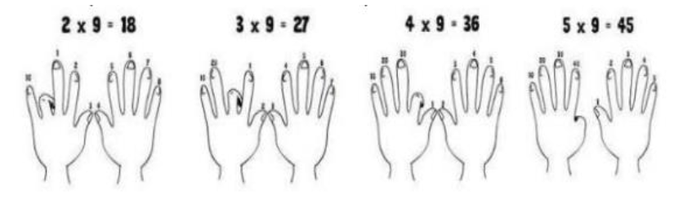
Eight Times Table The eight times table is double the four times table. So 7 x 4 = 28, 7 x 8 = 56, 56 is double 28. The units in the multiples of eight also go down in twos. 8, 16, 24, 32, 40, 48, 56, 64, 72, 80 (8, 6, 4, 2, 0, 8, 6, 4, 2, 0).

Nine Times Tables Fingers can be used to work out the nine times table up to 10 x 9. The first finger is put down for 1 x 9 and the remaining fingers show 9 units (1 x 9 =9). Then the second finer is put down for 2 x 9 and the remaining fingers show 1 ten (to the left) and 8 units (to the right) which equals 18, and so on.

Ten Times Table All the digits in the ten times table end in zero.

Eleven Times Table Most of the multiples in the eleven times table are recalled by putting two of the number side by side. 7 x 11 = 77, 8 x 11 =88.

Twelve Times Table The units in the twelve times table go up in twos. 12, 24, 36, 48, 60, 72, 84, 96, 108, 120, 132, 144 (2, 4, 6, 8, 0, 2, 4, 6, 8, 0). The multiples of 12 are also the multiples of 10 and the multiples of 2 combined.

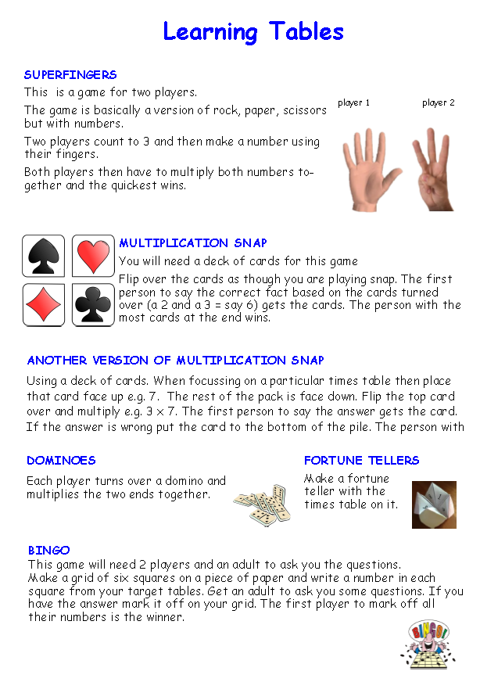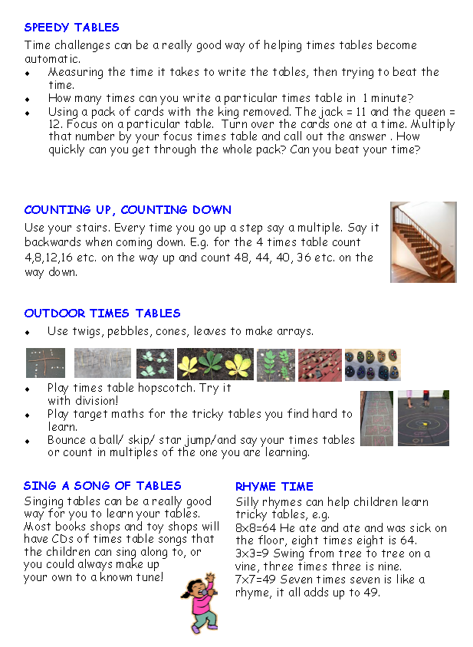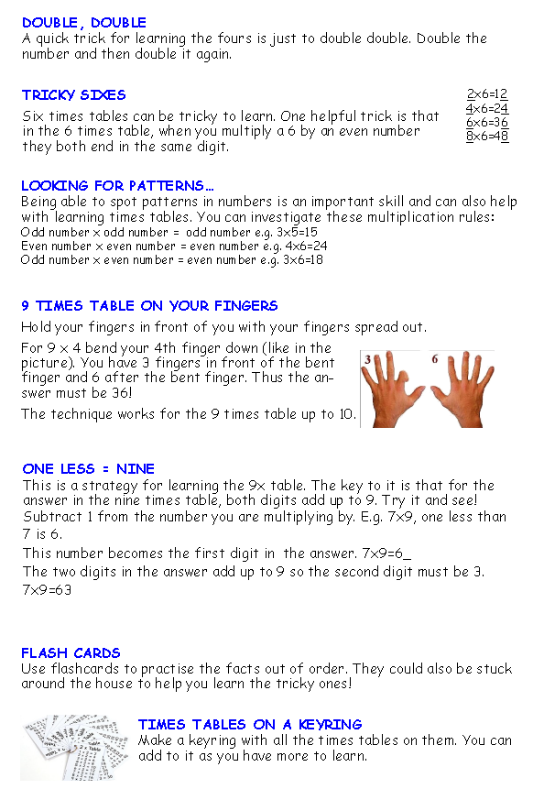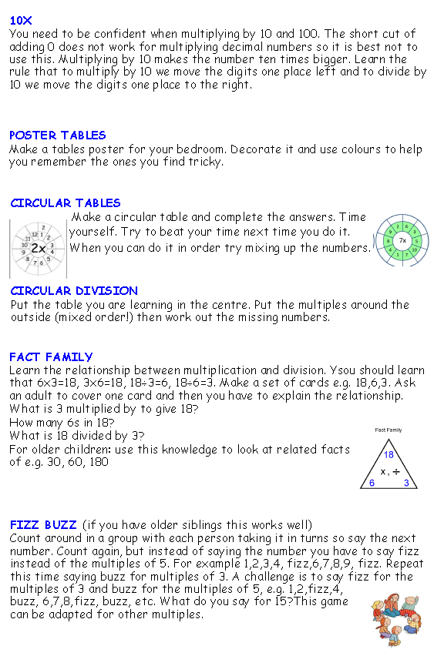
Times table with fact family reversal | Rhyme
4 x 12 and 12 x 4 | - At the park with my mate… 4 times 12 is 48  - I left the park a little late… 12 times 4 is 48
11 x 11 | - Fancy going for a run… 11 times 11 is 121
7 x 8 and 8 x 7 | - My house is made of bricks… 7 times 8 is 56  - This old house needs a fix… 8 times 7 is 56
4 x 6 and 6 x 4 | - Please sir, can I have some more?… 4 times 6 is 24  - More made my belly sore… 6 times 4 is 24
7 x 7 | - This one’s my favourite rhyme… 7 times 7 is 49
8 x 9 and 9 x 8 | - Get in line, there’s a queue… 8 times 9 is 72  - This long line will not do… 9 times 8 is 72
8 x 8 | - I ate and ate ‘til I was sick on the floor… 8 times 8 is 64
9 x 12 and 12 x 9 | - Saving the world is our fate… 9 times 12 is 108  - A beautiful world we’ll create… 12 times 9 is 108
6 x 7 and 7 x 6 | - Fancy a trip to the zoo? 6 times 7 is 42  - At the zoo, I saw elephant poo… 7 times 6 is 42
6 x 8 and 8 x 6 | - At the doctor’s, I had a long wait… 6 times 8 is 48  - The doctor said her name was Kate… 8 times 6 is 48
6 x 12 and 12 x 6 | - Above the clouds, the bird flew… 6 x 12 is 72  - The bird had an amazing view… 12 times 6 is 72
4 x 7 and 7 x 4 | - Zooming down, I roller-skate… 4 times 7 is 28  - Hurtling down towards the gate… 7 times 4 is 28
12 x 12 | - What’s that running past the door? 12 times 12 is 144
8 x 12 and 12 x 8 | - I saw a magician doing tricks… 8 times 12 is 96  - This magician had walking sticks… 12 times 8 is 96
6 x 9 and 9 x 6 | - Digging down to the core… 6 times 9 is 54  - I had to dig more and more… 9 times 6 is 54
4 x 8 and 8 x 4 | - Where’s my car? It’s brand new… 4 x 8 is 32  - This car is shiny blue… 8 times 4 is 32
7 x 12 and 12 x 7 | - Chicken tastes great, that’s for sure… 7 times 12 is 84  - Scrumptious chicken, I want more! … 12 times 7 is 84
11 x 12 and  12 x 11 | - Is that the train leaving for Crewe? … 11 x 12 is 132  - Before the train, let’s grab a brew… 12 x 11 is 132
Useful websites and games for practising times tables.

Times tables rock stars (log in at front of Learning Journal)
https://play.ttrockstars.com/
Purple Mash (log in at front of Learning Journal) https://www.purplemash.com
Search: Monster Multiplication
Top Marks www.topmarks.co.uk
Search ‘times tables’. Possible games: Hit the button, Mental maths train, Coconut
multiples, Fishy times tables, Tommy’s Trek, Super maths bowling multiplication,
Carroll Diagrams – multiples, Daily 10, Dartboard multiplication, Tables teaser and
many more…
ICT games www.ictgames.com
Click ‘Maths games’. Scroll to ‘Multiplication and division’. Games include: Times
tables tennis, Bunny battlefront, Pop n drop, Times tables truckers, Tug of war, Array
display.
Timestables.co.uk https://www.timestables.co.uk/games/
Mathsframe https://www.mathsframe.co.uk
Multiplication.com https://www.multiplication.com/games/all-games
Meteor multiplication https://www.arcademics.com/games/meteor
https://tablestest.com/
https://www.transum.org/Tables/Times_Tables.asp

